5G Academy
Fastweb + Vodafone Student Project Program
Gate Evaluation Report Template
Group Number | 4
Group Leader | Fauzan Ejaz
Group Members | Fauzan Ejaz (Leader), Adithya Zacharia Valavi, Ghazanfar Anees Siddiqui, Llagami Tedi
Project Title | AEGIS - Zero-Trust Identity for AI Agents on the Network
Gate | ☑ Gate 1 ☐ Gate 2 ☐ Gate 3
Submission Date | 7 September 2026

General Instructions
This document serves as the common template for the three progressive Gate evaluations required for each group's Proof of Concept (PoC) project. Each Gate corresponds to a distinct phase of the project and must be completed and submitted according to the schedule provided by the 5G Academy.
Please complete only the relevant section for the Gate you are submitting, keeping the cover page information updated each time.

GATE 1 - Technologies, Planning & Feasibility
This Gate report should cover the technologies involved, the project schedule, the feasibility of the proposed idea, and, where possible, an economic/business analysis.

1.1 Technologies
Describe the key technologies relevant to your project (e.g. 5G features, network functions, devices, protocols, tools):
AEGIS applies a Zero-Trust security model to the identities of the AI agents and automations that operate the 5G control plane. It combines a telecom control-plane surface, a zero-trust security paradigm, and behavioural machine learning:
5G control-plane surface - the 5G Service-Based Architecture (SBA) and Service-Based Interface (SBI): Network Functions (AMF, SMF, NRF, PCF, UDM, NEF) exposing HTTP/2 REST APIs - the same interfaces that orchestration, OSS and closed-loop-automation agents call.
Zero-Trust security (NIST SP 800-207) - continuous, per-request verification of machine identities (“never trust, always verify”), applied to behaviour rather than to credentials alone.
Behavioural fingerprinting & anomaly detection - unsupervised machine learning (Isolation Forest) trained only on legitimate traffic, combined with deterministic policy rules and a session-level state machine that validates PDU-session call sequences.
Detection features - request rate and inter-arrival timing, distinct Network Functions / endpoints, method mix, call-sequence integrity, error rate, payload size, and time-of-day.
Data & tooling - a synthetic 5G SBA traffic generator (Python) produces labelled data with injected attacks; scikit-learn and pandas for modelling; a Streamlit dashboard implements the zero-trust gate (PASS / STEP-UP / BLOCK). Real M2M / API-gateway logs can be ingested if provided.
Deployment vision - in production the gate runs as an inline policy check at the network edge (FASTedge); the PoC runs offline on replayed logs.
Standards & frameworks - NIST SP 800-207, 3GPP SBA, TM Forum closed-loop automation (OODA); aligned with NIS2, GDPR and the EU AI Act.

1.2 Project Schedule (Gantt Chart)
Insert or attach the Gantt chart showing project milestones, tasks, and timeline:
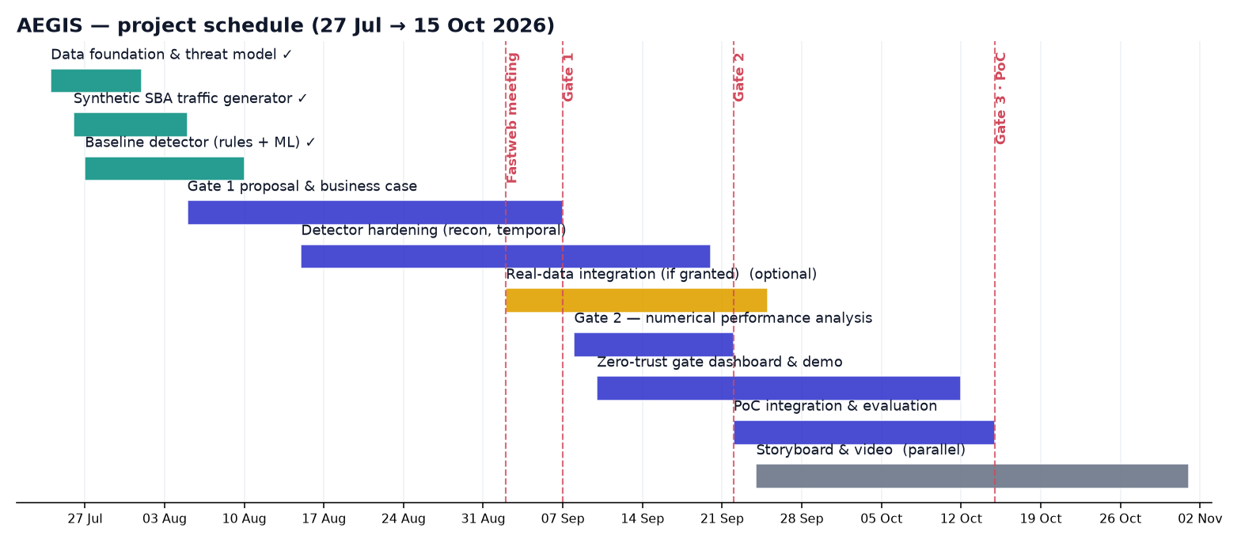
Briefly summarize the main phases and key deadlines:
- Phase 1 - Foundation & baseline PoC (threat model, synthetic 5G SBA data, rules + ML detector) - Deadline: 10 Aug 2026 (completed).
- Phase 2 - Technical solution & evaluation (feature hardening, numerical performance analysis, gate dashboard, optional real-data integration) - Deadline: Gate 2, 22 Sep 2026.
- Phase 3 - Final Proof of Concept & video (integration, live zero-trust gate demo, storyboard & shooting) - Deadline: Gate 3, 15 Oct 2026.

1.3 Feasibility Analysis
Discuss the technical feasibility of the proposed solution (resources, constraints, risks):
The solution is technically feasible and already de-risked by a working baseline prototype:
Resources - entirely open-source (Python, scikit-learn, Streamlit); no specialised hardware, it runs on a standard laptop. Production adds only lightweight edge compute at FASTedge.
Data availability - the main external risk (access to real network traffic) is fully mitigated: the PoC is synthetic-first. A 3GPP-grounded generator produces realistic, labelled SBA traffic; real logs are an upgrade, not a dependency.
Evidence of feasibility - the working baseline already detects all seven modelled threat classes on 11,343 held-out request windows, at ROC-AUC 0.99, 98% recall and a 0.8% false-positive rate.
Key risks and mitigations:
Risk | Mitigation
Synthetic data may not capture real agent behaviour | Modelled on 3GPP SBA semantics; the pipeline ingests real logs when available.
False positives disrupt operations | Held-out calibration + a soft STEP-UP action before BLOCK; thresholds are tunable.
Real-data access is not granted | The full PoC is deliverable on synthetic data alone.
Adaptive / evasive attackers | Layered rules + ML + session state machine; roadmap for periodic retraining.

1.4 Economic / Business Analysis (where applicable)
Provide an estimate of costs, potential business value, and/or market relevance, if applicable to your project:
Illustrative value model, to be validated jointly with Fastweb + Vodafone:
Cost - development is engineering time only (open-source, existing compute, no licensing). Production cost is modest edge compute for the inline gate.
Risk avoided - detecting a compromised or spoofed automation before it acts on the control plane cuts mean-time-to-detect from hours to seconds and contains blast-radius, avoiding outage and breach costs.
Enabler of safe automation - zero-trust on machine identities is the guardrail that lets the operator safely expand network automation (closed-loop / self-healing), protecting the value of the wider AI-native roadmap.
Compliance & audit - supports a NIS2 zero-trust posture; explainable, logged decisions provide audit evidence for GDPR and the EU AI Act.
Operational efficiency - automates machine-identity monitoring that cannot be performed manually at API scale.
Market relevance - securing AI agents on critical infrastructure is an emerging, board-level priority; AEGIS targets a gap that credential-based AAA does not cover.
GATE 2 - Technical Solution & Architecture
This Gate report should cover the proposed technical solution, with a clearly defined architecture and implementation strategy, a complete numerical performance analysis, and a clear description of the expected Proof of Concept (PoC).

2.1 Proposed Technical Solution
Describe the overall solution you propose to address the project's objective:
[Enter description here]

2.2 Architecture
Provide a clear diagram and description of the system architecture:
[Insert architecture diagram and description here]

2.3 Implementation Strategy
Describe how the solution will be implemented step by step (tools, platforms, methodology):
[Enter implementation strategy here]

2.4 Numerical Performance Analysis
Provide quantitative results, simulations, calculations, or expected performance metrics supporting your solution:
[Insert numerical analysis, tables, or graphs here]

2.5 Expected Proof of Concept (PoC)
Clearly describe what the PoC will demonstrate and how it validates the proposed solution:
[Enter PoC description here]

GATE 3 - Proof of Concept (Final)
This Gate report should present a fully functional Proof of Concept demonstrating the core features and technical feasibility of the proposed solution.

3.1 PoC Overview
Summarize what the final Proof of Concept demonstrates:
[Enter overview here]

3.2 Core Features Demonstrated
- Feature 1: ____________________
- Feature 2: ____________________
- Feature 3: ____________________

3.3 Technical Feasibility - Results
Present the results obtained, evidence of functionality, and validation of technical feasibility (screenshots, logs, measurements, etc.):
[Enter results and supporting evidence here]

3.4 Video Demonstration
Reference or link to the video recording of the PoC (as scheduled with the videomaker):
[Insert video link/reference here]

3.5 Conclusions & Lessons Learned
Summarize the outcomes, challenges faced, and key takeaways from the project:
[Enter conclusions here]

